

Foundations of Programming

Assignment No. : 06
PROBLEM STATEMENT:Write a C function to compute the factorial of a number with and without recursion.

OBJECTIVE:

To demonstrate two different approaches for calculating the factorial of a number: iterative (non-recursive) and recursive, showcasing the versatility of problem-solving methods in programming.

THEORY:
- Explain the difference between the iterative and recursive approaches to calculating the factorial of a number.
- What is the base case in the recursive function for computing factorials, and why is it necessary?
- How does the program handle invalid input, such as negative numbers, and why is this important?
PLATFORM: Linux
ALGORITHM:
1. Iterative Approach (Non-Recursive)
- Start.
- Initialize a variable fact = 1.
- Read the input number n.
- If n < 0, return an error (factorial is not defined for negative numbers).
- Loop: For each integer i from 1 to n:
  - Update fact = fact * i.
- Return fact.
- End.
2. Recursive Approach
- Start.
- Read the input number n.
- Base Case: If n == 0 or n == 1, return 1.
- Recursive Step: If n > 1, return n * factorial(n - 1).
- End.

FLOWCHART:
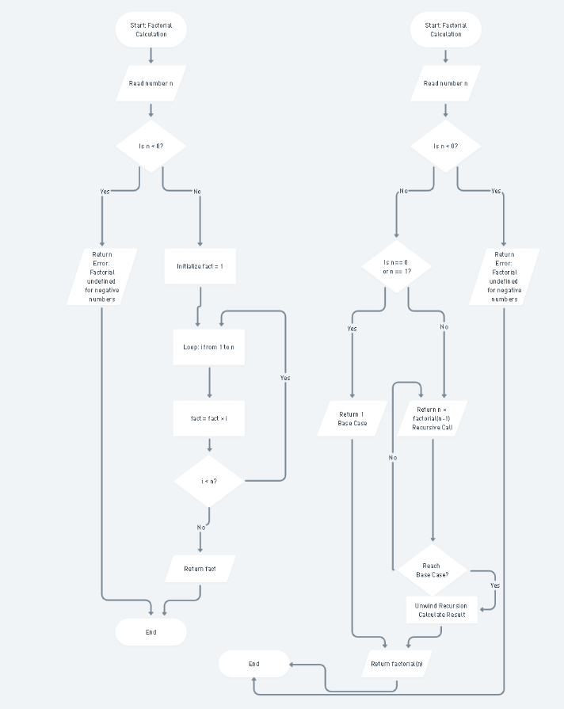
CODE:
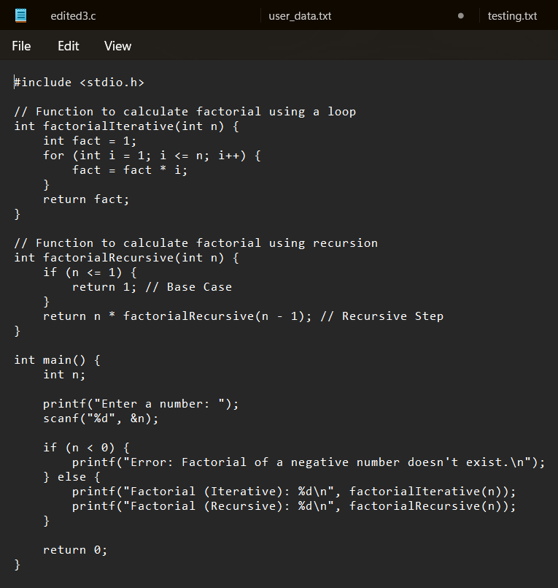

INPUT/OUTPUT:

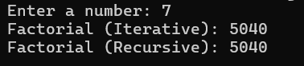
CONCLUSION: Thus, we have successfully executed factorial of a number with and without recursion.

FAQs:
1. What is the purpose of calculating factorial in programming?
2. What is the difference between recursive and non-recursive (iterative) methods?

